Data Loading (ETL)

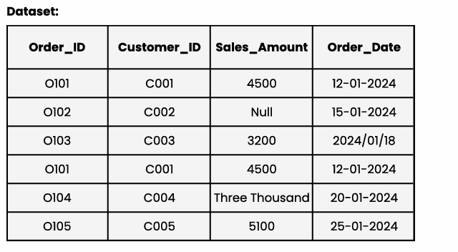

Q1. Data Understanding
Identify all data quality issues present in the dataset that can cause problems during data loading.
Solution: Issues include missing values, duplicate Order_ID, inconsistent date formats, non-numeric Sales_Amount, and text-based numbers.
Q2. Primary Key Validation
Assume Order_ID is the Primary Key.
a) Is the dataset violating the Primary Key rule?
Ans : Yes
b) Which record(s) cause this violation?
Ans: Duplicate Order_ID = O101 violates primary key rules.

Q3. Missing Value Analysis
Which column(s) contain missing values?
a) List the affected records
Ans: Missing values exist in Sales_Amount (C002).
b) Explain why loading these records without handling missing values is risky
Ans: Loading without handling can cause null aggregates, incorrect KPIs, and SQL load errors.

Q4. Data Type Validation
Identify records where Sales_Amount violates expected data type rules.
a) Which record(s) will fail numeric validation?
Ans : Record C004 ('Three Thousand') fails numeric validation.
b) What would happen if this dataset is loaded into a SQL table with Sales_Amount as DECIMAL?
Ans: SQL will reject or fail loading due to conversion error.

Q5. Date Format Consistency
The Order_Date column has multiple formats.
a) List all date formats present in the dataset
Ans: Formats: DD-MM-YYYY (12-01-2024), YYYY/MM/DD (2024/01/18).
b) Why is this a problem during data loading?
Ans: Causes parsing errors and inconsistent date storage.

Q6. Load Readiness Decision
a) Should this dataset be loaded directly into the database? (Yes/No)
Yes: No.
b) Justify your answer with at least three reasons
Ans: Reasons: duplicate keys, missing values, inconsistent date formats, non-numeric sales values.

Q7. Pre-Load Validation Checklist
List the exact pre-load validation checks you would perform on this dataset before loading.
Solution:
- Duplicate check
- Primary key validation
- Null value scan
- Data type validation
- Date format standardization
- Referential integrity validation

Q8. Cleaning Strategy
Describe the step-by-step cleaning actions required to make this dataset load-ready
Solution:
1. Remove duplicates
2. Impute or fix missing values
3. Convert dates to single standard format
4. Convert non-numeric values to numeric
5. Validate keys

Q9. Loading Strategy Selection
Assume this dataset represents daily sales data.
a) Should a Full Load or Incremental Load be used?
Ans: Incremental load
b) Justify your choice.
Ans: Incremental load because daily data comes repeatedly and avoids reloading historical data.

Q10. BI Impact Scenario
Assume this dataset was loaded without cleaning and connected to a BI dashboard.
a) What incorrect results might appear in Total Sales KPI?
Solution :
- Total Sales will be over-reported because duplicate Order_ID (O101) will be counted twice.
- Null Sales_Amount will cause under-reporting or be ignored, reducing total wrongly.
- Text value (“Three Thousand”) may cause calculation errors or BI may skip that record entirely.
- Final KPI will be mathematically incorrect and misleading.

b) Which records specifically would cause misleading insights?
Solution :
- Duplicate Record:
  - Order_ID = O101 (appears twice) → inflates total sales.
- Missing Sales Amount:
  - Customer_ID = C002, Sales_Amount = NULL → reduces total or gives blank values.
- Invalid Sales Amount (text instead of number):
  - Customer_ID = C004, Sales_Amount = “Three Thousand” → causes numeric error.

c) Why would BI tools not detect these issues automatically?
Solution :
- BI tools visualize data, they don’t validate quality.
- They assume ETL has already cleaned and prepared the data.
- They cannot detect business rule violations like duplicate Order_ID.
- They do not check data types — text values are treated as text, not errors.
- They aggregate values blindly without integrity checks.

